TAGORE DENTAL COLLEGE AND HOSPITAL
DEPARTMENT OF ORAL AND MAXILLOFACIAL SURGERY

GUEST LECTURE BY
Dr. Karthick Shekar
Adjunct Faculty at Tagore Dental College and Hospital
Department of Oral and Maxillofacial Surgery
University of Malaya, Malaysia.

DATE: 2.2.2021

Venue:
Conducted online through official Google meet application

DEPARTMENT OF ORAL AND MAXILLOFACIAL SURGERY
TAGORE DENTAL COLLEGE AND HOSPITAL
MELAKOTTAIYUR POST, RATHINAMANGALAM
CHENNAI – 600127
PH: 044 – 3010 2222, EXTN: 228 / 230
EMAIL ID: maxfacs@tagoredch.in

PROF.M.MALA DR.CHITRAA R. CHANDRAN
CHAIRPERSON PRINCIPAL
ORGANIZING COMMITTEE:
PROF.DR.S.JIMSON
DR.ISRAEL NATHANAEL

Topic of the session: Impaction and complications of impaction(VIRTUAL)
Organizer: Department of Oral and Maxillofacial Surgery, Tagore Dental College & Hospital
Date: 2nd FEBRUARY, 2021
Learning Outcome: To acquire detailed knowledge and clarification in surgical removal of impacted teeth,management and complications involving it.
Venue: Conducted online through official Google meet application.

FACULTY:
- Dr. Karthick Shekar
Adjunct Faculty at Tagore Dental College and Hospital
Department Of Oral and Maxillofacial Surgery
University Of Malaya.

MODERATOR:
1. Dr.Israel Nathanael
Senior Lecturer
Department of Oral and Maxillofacial Surgery
Tagore Dental College and Hospital.

TOPICS COVERED
1. Surgical Removal of Impacted Teeth.
2. Complications involving surgical removal on third molar teeth

The session was started by Prof.Dr. Jimson with a welcome speech, following which the Guest speaker was introduced by Dr.Israel Nathanael.
The lecture commenced by 9.30 am, a detailed, evident and highly informative presentation on impaction and its complications was given. Ample opportunities for questioning were provided to the students and following the presentation, a discussion session was held .The lecture concluded by 10.30 am.
It was attended by 86 undergraduate students and 2 faculties.

Pictures:

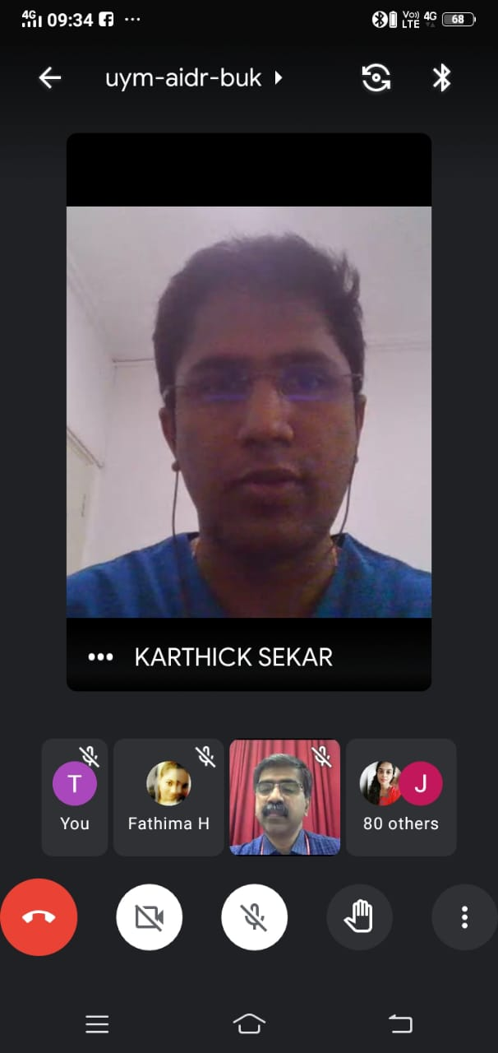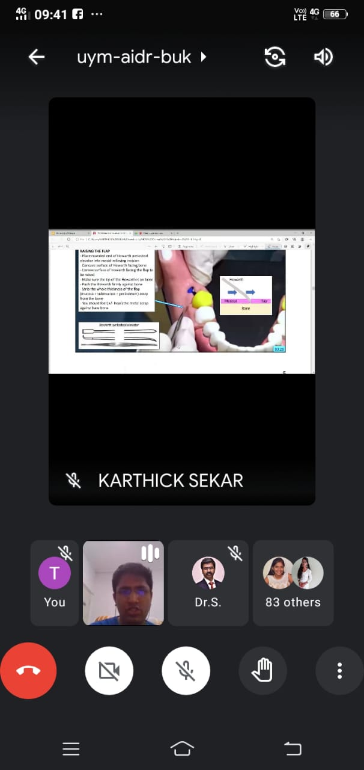

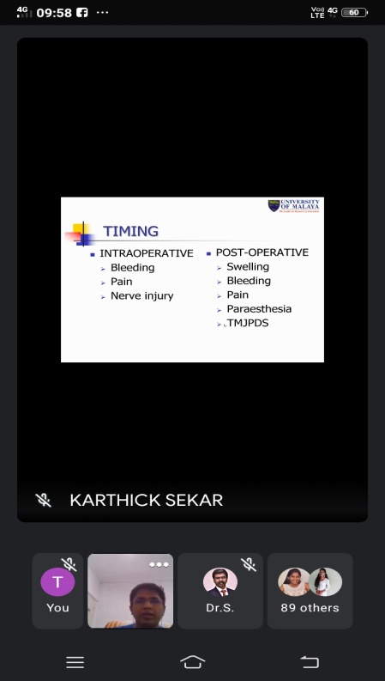

PREETHA J H
PRIYA S
PUVITHA A
RAGAPRIYA
RAJ SHREE E
RAKSHNA N
RAMYA M
RESHMA S
RITHIKA SRI S
SAROJINI
SETHU SREE G
SHARMILA E
SHREEYAN NAYAR M N
SHRIKAVI M
SHREELAKSHMI
SIVARANJANI S
SRIDEVI S
SRIJANANI S
STAVAN V
SUBASH B
SUBASH M
SUGUMARI
SUMAIYA B
SUMAIYA FATHIMA T
SUNIL KUMAR
SUTHAMANCHARRI S
THILAKRAJ S
VASANTHAN R M
VETHIKA K
VIVETHA
YOGESH PERIYASWAMY
SHREELEKHA
REVATHI
AVINASHMOORTHI
DIWAKAR

STUDENTS

AARTHI P
AARUDRADEVI J G
ABHITHA SHREE S
AISHWARYA K
AISHWARYA S
AJAI KUMAR
AJITH KUMAR S
AKASH V
AKSHAYA N
ANITHA ROSELIN S
ANJALI V
ANUSIYA J
ASHWINI D
AYISHA M
BAKYA LAKSHMI V
BALAJI S A
BHARANY MALAVIKA J
BHARGAVI T
BHAVANKUMAR V
DEEPAK RAJ J
DEEPIKA BARATHI M
EZHIL BHARATHI I
FATHIMA HASEEN FAZEENA
GOKULA PRIYA R
GAYATRI
GOPINATH B
GOWARDHAN S
HARITHA R
JANANEE BHARKAVI N
JANISHA M
JEBASELVI P
JEYAMITHA R
KALKI PRIYA A
KALPITA DEB BARMAN
KAMIL HANEEF
KANMANI
KARTHIKEYAN A
KRISHNA PRIYA
KRITHIKA A
LAKSHAYA
MALARVIZHI G
MARIA SELVA VIVETHA A
MONISHA N C
MUTHU MEENAL M
NAFEESA
NIRMALA S
NISHA DAPHNE R
NISHAALI M M
PAVITHRA M
POOJA DHARSHINI R
PRAVINA

STAFFS

DR.S.JIMSON
DR.ISRAEL NATHANAEL

